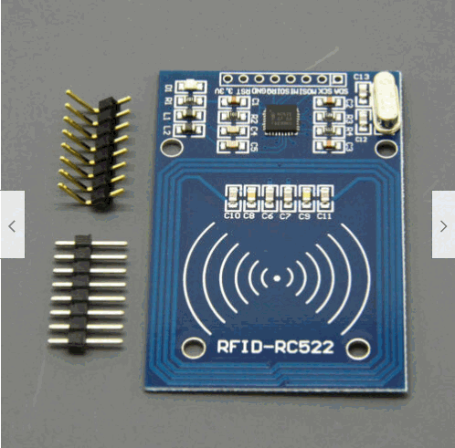

Frequency is 13.56 MHz
See the PDF for memory details. I limit the writes to 16 bytes. I use section 1 blocks 4,5,6 and section 2 blocks 8,9 section 3 blocks 12 (see Arduino code “checkRFIDcard”)
I use 12mm laundry tags (14mm will fit too) on HO trucks. Make sure you get the Mifare Classic 1K or my code won’t read it.
12mm tag reads when held about 1/8 inch above the rails. 25mm tag reads about ¾ inch above the rails. (the bigger the tag the better.)
I use the ‘on-board’ antenna with no problems.
The antenna is not sensitive enough to use GLASS Tag.

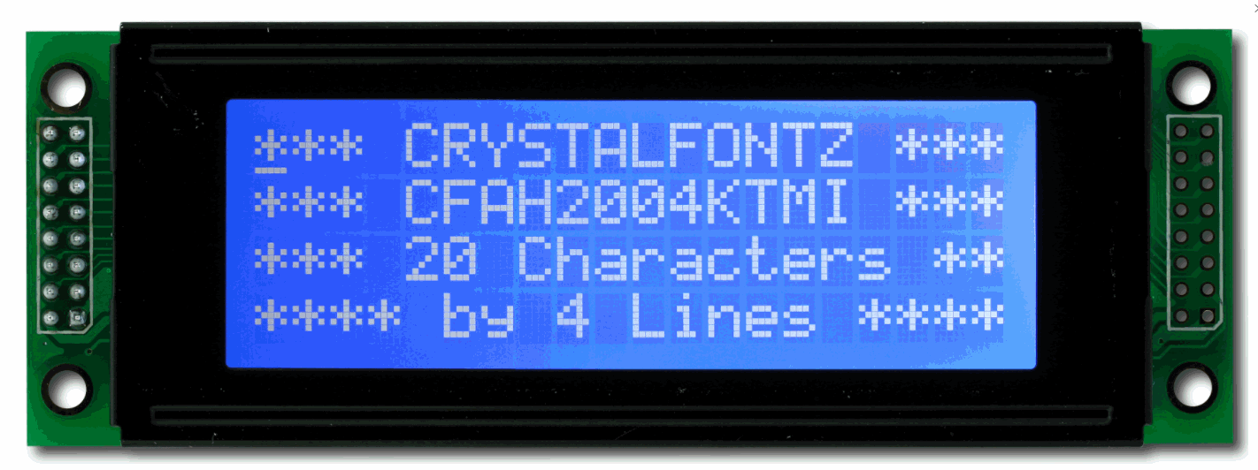

I use the 4 line LCD make sure it has the I2C daughter board on the back.

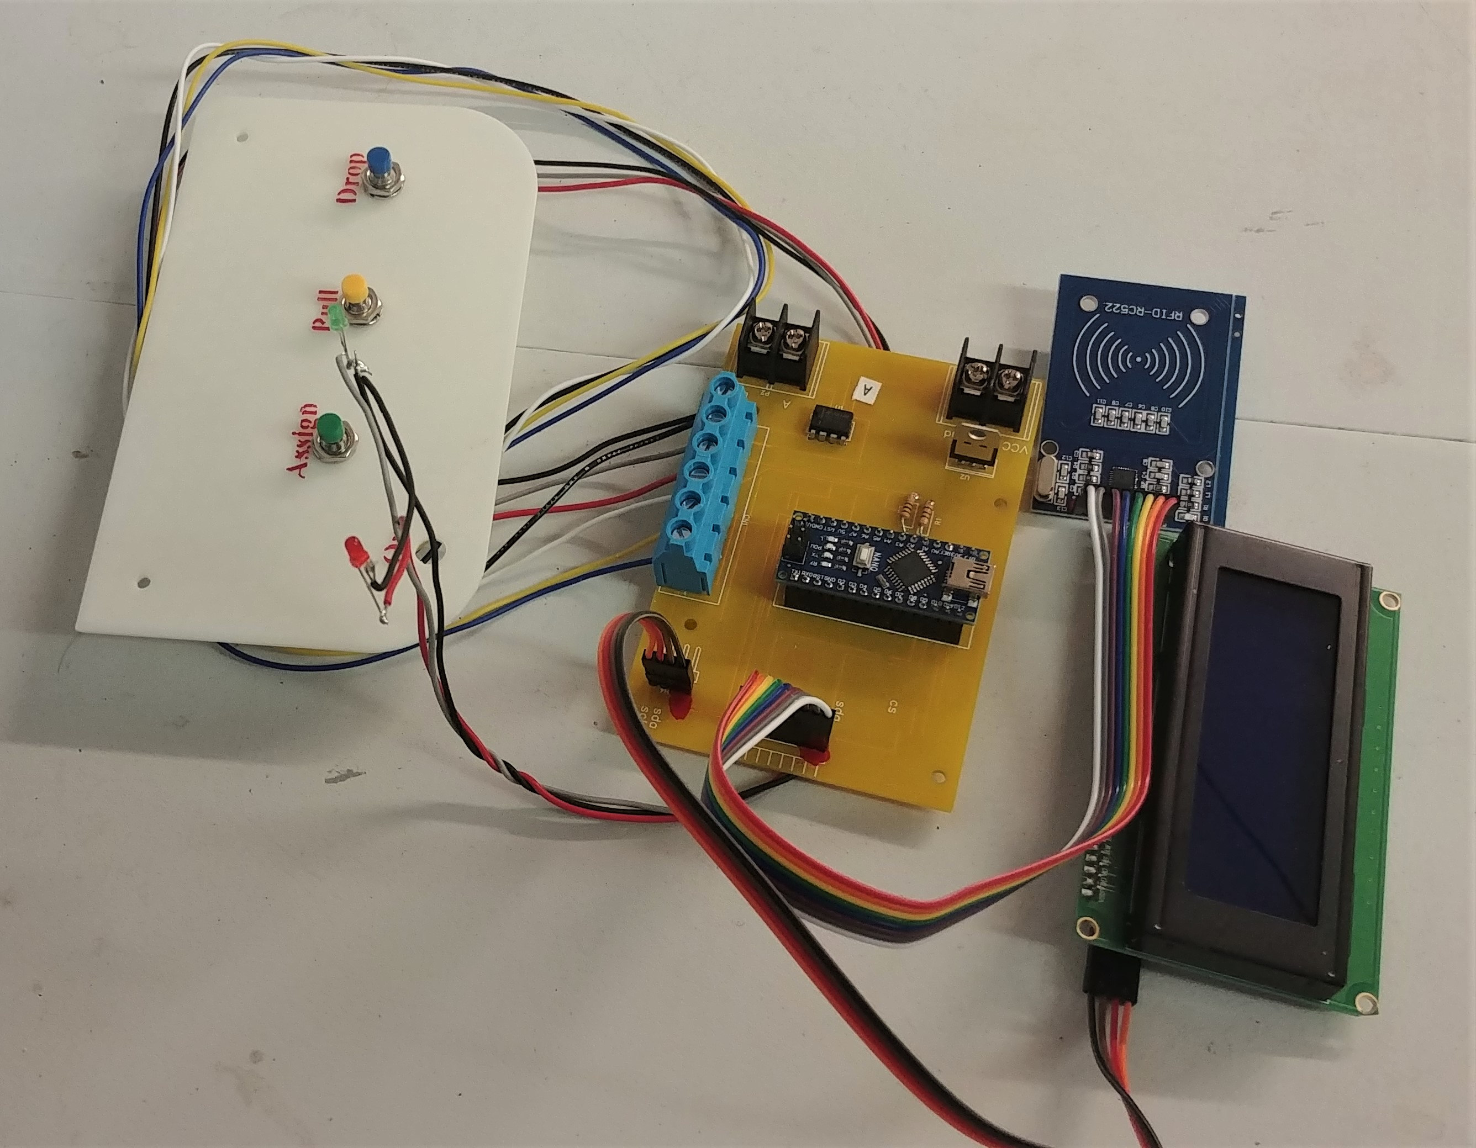
I 3D printed the local panel
I tested the RC-522 with antenna side up and blank backside up and it makes no difference for read distance. I will lay mine in with the bank side up as it makes it easier to hide the crystal can.

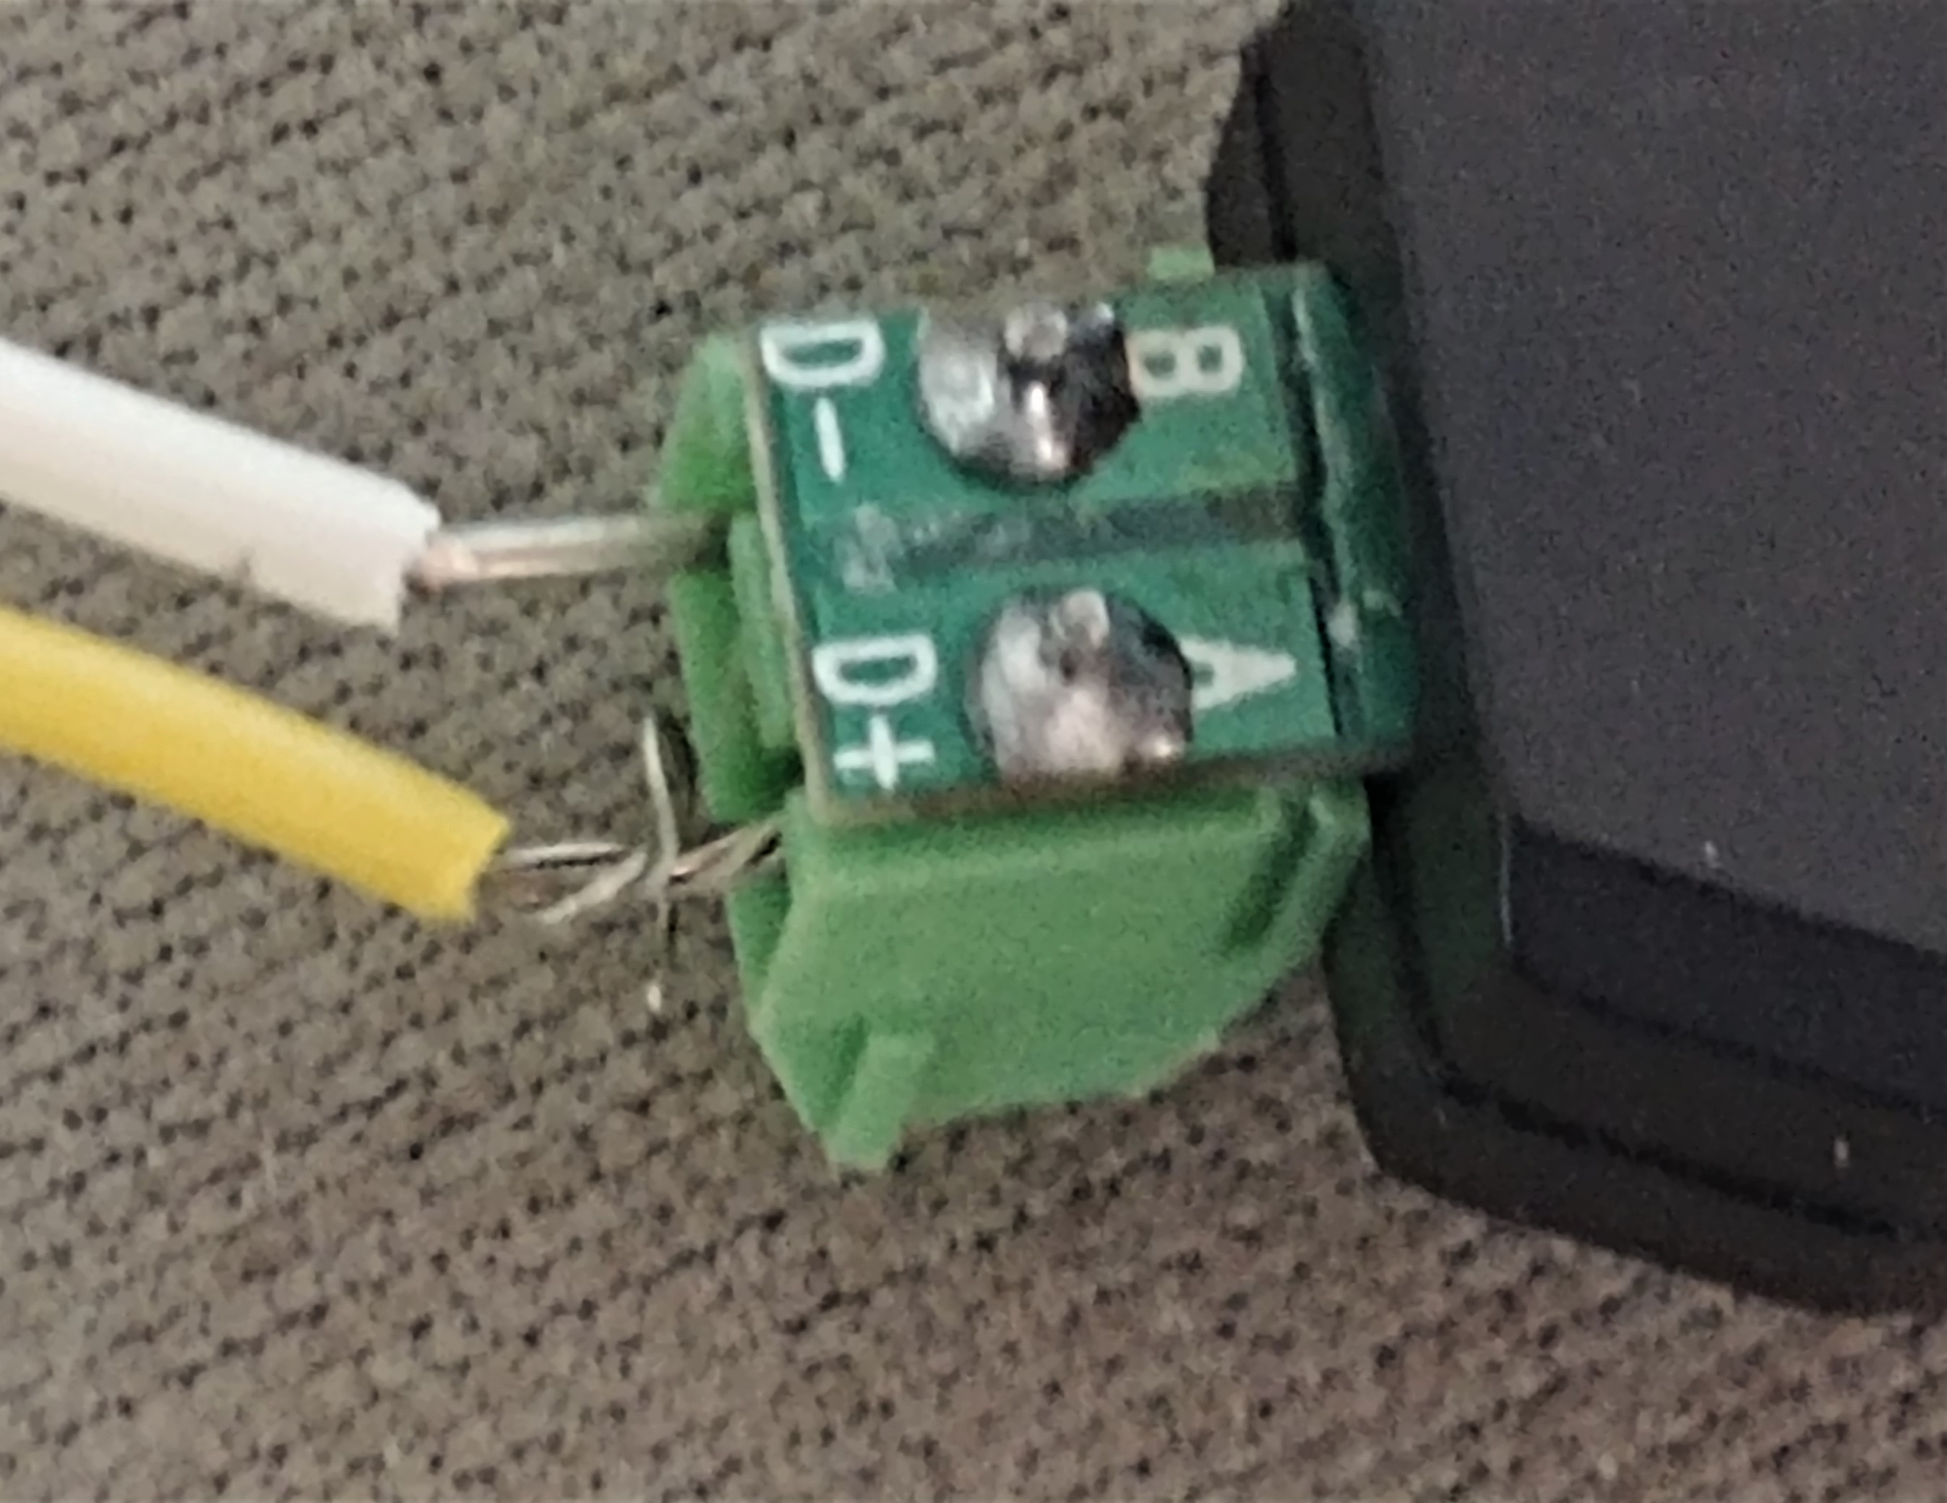
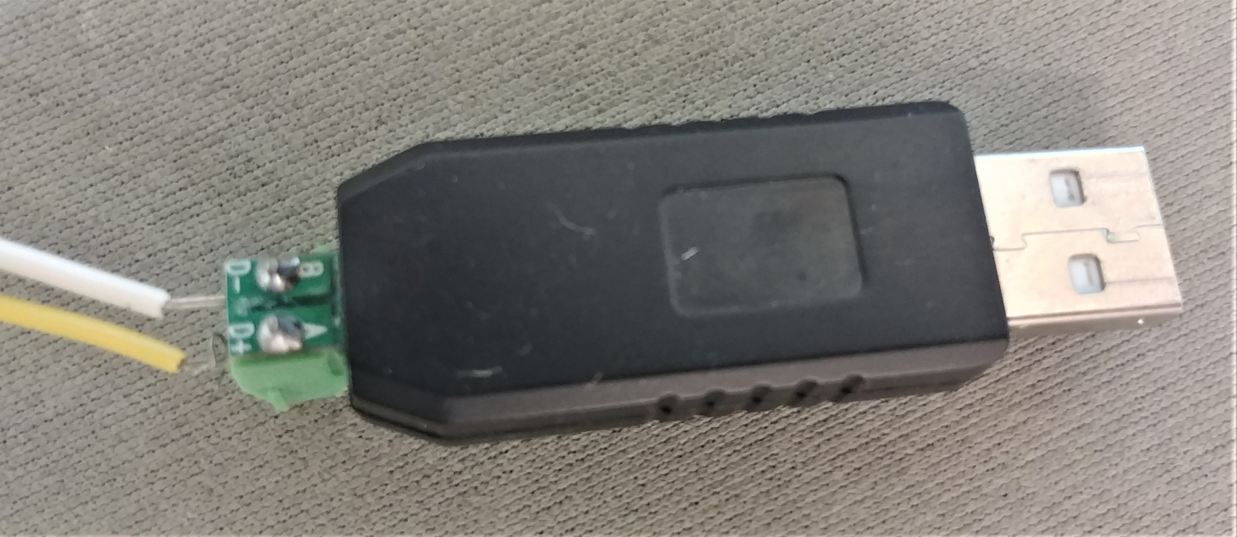
This is the USB to RS-485 converter that I use. Any wire is okay, I use 22 AWG, and it connects to the board (terminal A to terminal A) and (B to B). I have the boards marked with A and B. They simply daisy chain all the other boards A to A to A and B to B to B.

